Version Control Setup

Bulldogs Racing
BR2016
Yale University

June 2, 2015

Overview

This document is designed to walk Bulldogs Racing members through the process of setting up version control on their local computers. Subversion (SVN) is the version control system used by Bulldogs Racing. It keeps track of a file's history as it is changed by various members of the team. Additionally it allows users to lock files that they are working on so that other users do not work on that file at the same time. This prevents two users from changing the same file at the same time and interfering with each other's work.

TortoiseSVN

TortoiseSVN is a graphical client that integrates directly into Windows explorer. It can be downloaded here in both 32 bit and 64 bit executables. Additionally this link is for the official TortoiseSVN tutorial, of which the preface and chapters 1 and 2 are the most important. Chapter 4 is a more exhaustive source of information that can be used as a reference.

SmartSVN

SmartSVN is a SVN client that supports Windows, Mac and Linux. Mac and Linux users will have to use SmartSVN, whereas Windows users have the choice of using SmartSVN if TortoiseSVN is deemed unsatisfactory. SmartSVN can be downloaded here and has an official tutorial here.

Assembla

The BR2016 repository is hosted by a version control hosting web service called Assembla. Assembla is a combination of version control, ticketing system, time tracking, and communications platform. Bulldogs Racing will primarily use Assembla as a version control platform, however it may also be useful for ticketing. The Assembla home page is pictured in Figure 1, and the BR2016 home page is pictured in Figure 2. The versioned files can be viewed under the SVN → Source tab. A list of additions to the repository can be viewed under the SVN → Commits tab.

All commits to the repository must go through a merge request. This is done in order to ensure that the proposed change is up to repository standards. The following Assembla article details how the merge request process. In summary it involves creating a new branch, committing to the branch, then issuing a merge request.

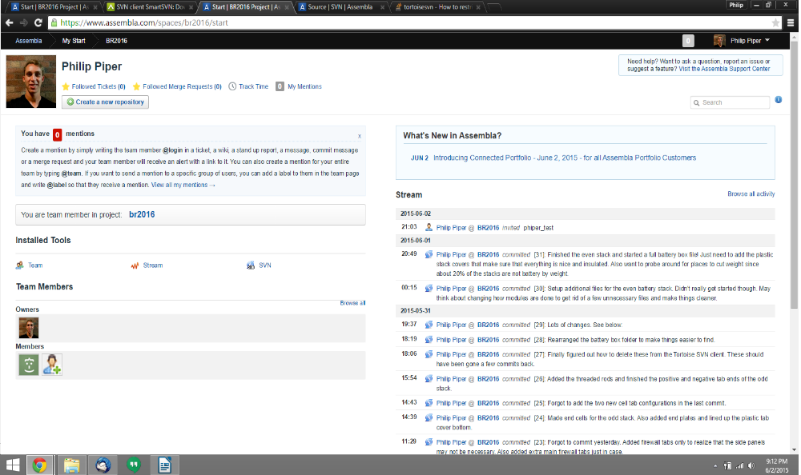Figure 1: Assembla home page picturing a very handsome, young man.
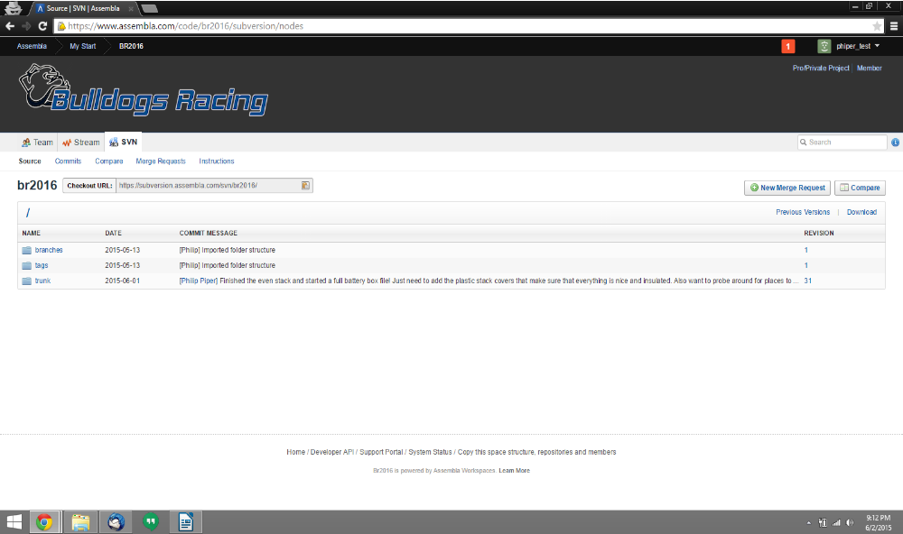Figure 2: BR2016 Assembla page with a sick logo and some nifty CSS work.

Checkout

In order to get a working copy of the repository, Subversion requires end users to “checkout” the repository. This process copies the repository in its entirety to the user's local machine such that it can be modified, and later committed back into the Assembla-hosted repository.

- First the directory that will hold this copy must be made. Create an empty folder called “BR2016” on your local machine.
- To initiate the checkout process, right click on the new, empty, folder and select “SVN Checkout...”.
- A prompt will pop up that asks for the “URL of the repository”. Look at the top of Figure 2, and note that there is a box containing the “Checkout URL”. Navigate to the BR2016 Assembla page and copy-paste this URL into the TortoiseSVN prompt.
- The “Checkout directory” should be the new folder that you created called “BR2016”.
- “Checkout Depth” should be set to the default of “Fully recursive”.
- “Revision” should be set to the default of “HEAD revision”.
- Press “OK” to confirm the SVN checkout

Merge Request and Commit

